1.6 Piecewise Functions

Definition: A piecewise function is defined by using 2 or more rules on 2 or more intervals; as a result, the graph is made up of 2 or more pieces.

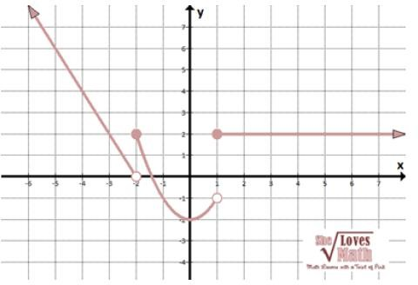Ex 1: Determine an equation to represent *f(x):*

Is this function continuous?

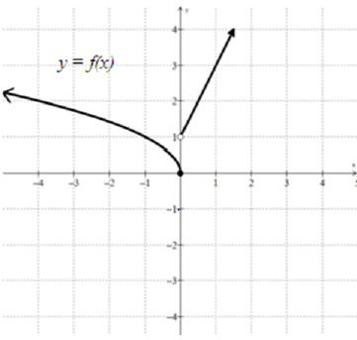Ex 2: Determine an equation of:

Ex 3: Graph this function:

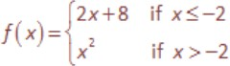

Is it continuous?

Ex 4: Algebraically determine if the function below is continuous or not. If not, you must identify where it is discontinuous.

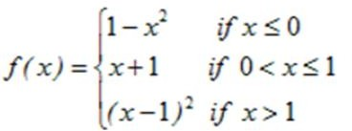

Ex 5: Write the basic absolute value function as a piecewise function:

Ex 6: Write the absolute value function below as a peicewise function:

